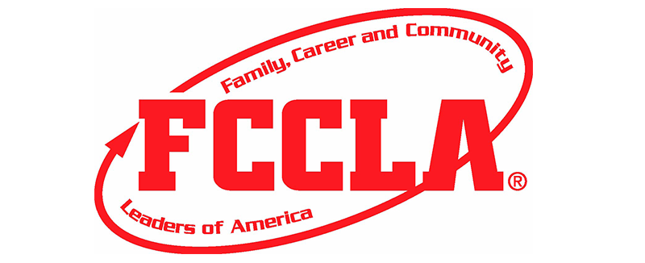
Iowa Association of
Family, Career, and Community
Leaders of American

Spring Meeting – Sunday, April 19, 2026 – 7:30 PM – Zoom Meeting
- Call to Order President Regina Rains
- Roll Call Secretary Mekayla Schilling
- Peer Education Courtney Roll
- Financial Report Michael Weber
- State Adviser Report Sherry Vogel
  - Membership
  - Packages
  - Board makeup
  - State Conference Review
  - State officer selection and review
  - National Plans
  - Fall Rallies
  - Summer workshops??
- Presidents Report Regina Rains
  - Iowa Adviser report year 2
- Next Meeting??
June _______________ time:____________________
- Adjournment

